WORKOUT LOG

User Guide
  - How to record workouts review history and understand progress
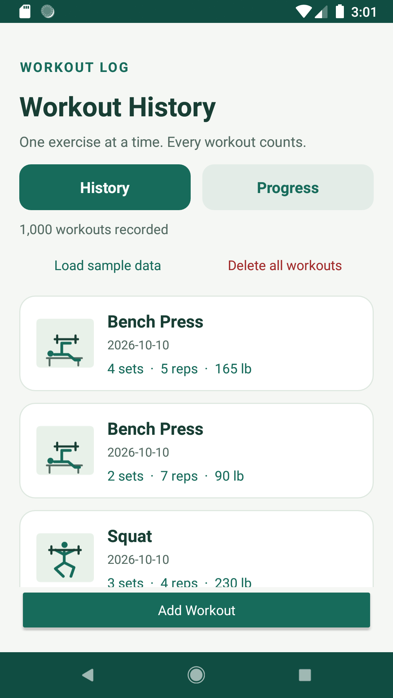
Workout Log running on Android 8.1
Version 1.0 Android 8.1 Offline storage

Start Here
Workout Log records one exercise per entry and keeps the data on the device. Use the History tab to add and review workouts. Use the Progress tab to see summary totals charts and personal records.

Quick Start
- Open the app and select Add Workout.
- Choose an exercise and confirm the workout date.
- Enter the number of sets and repetitions per set.
- Optionally enter weight in pounds and notes.
- Scroll to the bottom of the form and select Save Workout.
Required fields Exercise date sets and repetitions are required. Weight and notes are optional.
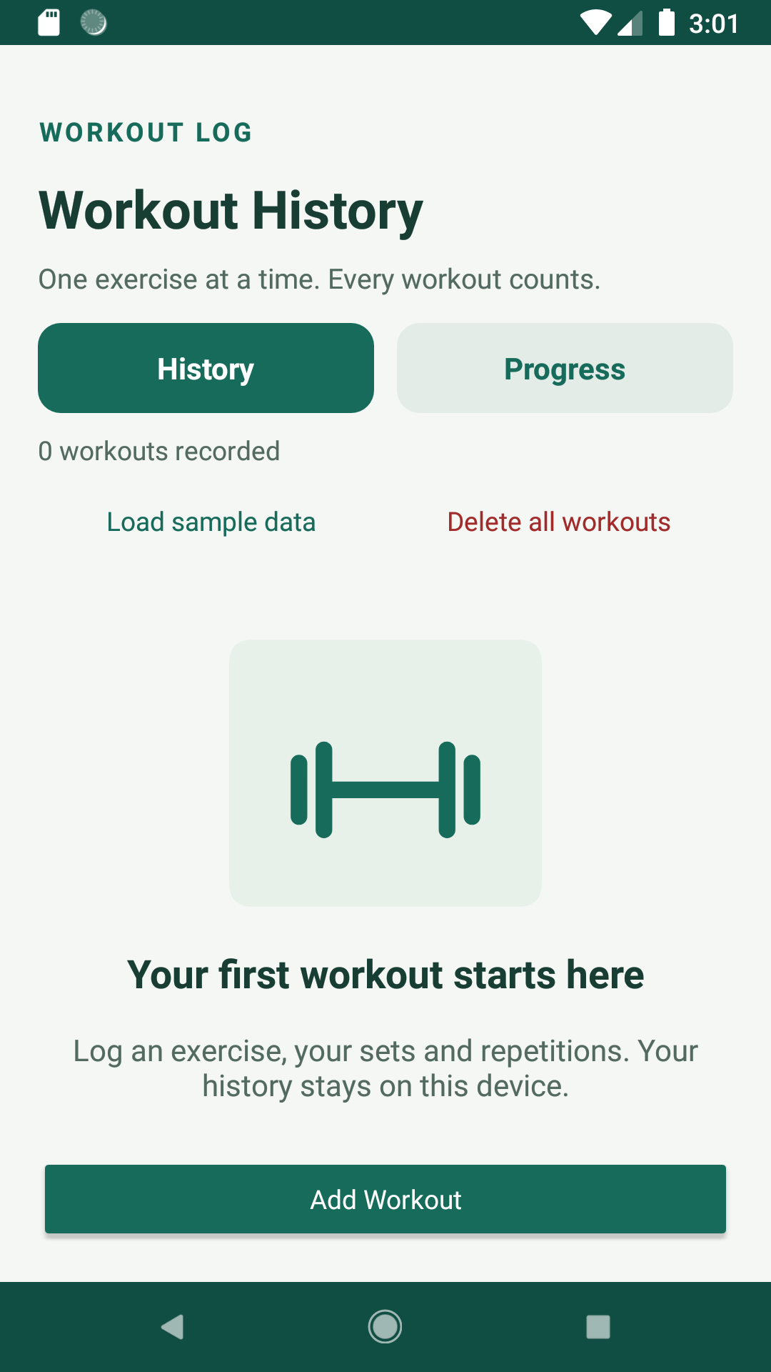
The History screen before any workouts have been recorded

Add a Workout
Select Add Workout from either main tab. The form records one exercise with the same repetitions and weight for every set in that entry.
- Open the Exercise list and choose a built in or custom exercise.
- Select the displayed date if you need to record a different workout day.
- Enter whole numbers for Sets and Repetitions per set.
- Enter Weight in pounds if the exercise uses added resistance.
- Enter optional notes such as technique changes or how the workout felt.
- Scroll down and select Save Workout.
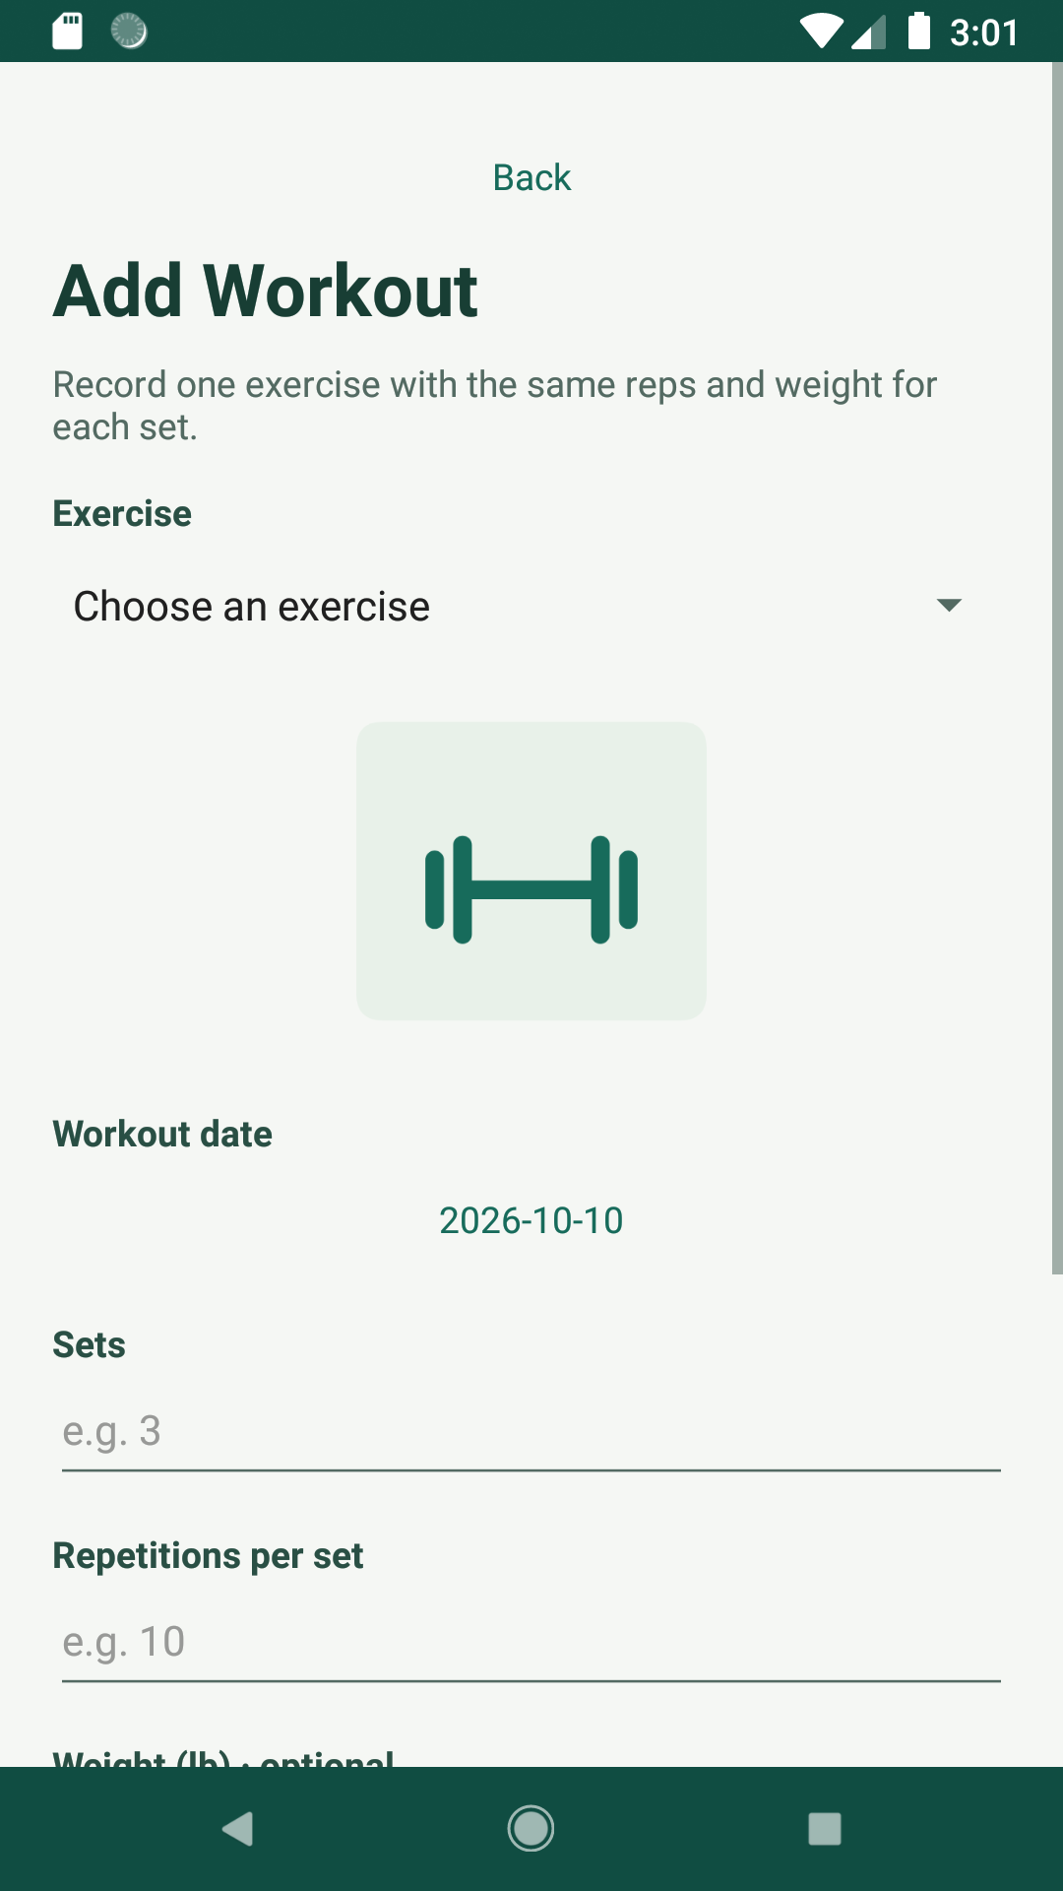
The Add Workout form
Date format The app displays dates as yyyy-MM-dd, so 2026-10-10 means October 10, 2026. Choose today or an earlier date.

Choose or Create an Exercise
The app includes Bench Press Deadlift Push up Shoulder Press and Squat. You can also add your own exercise from the same list.
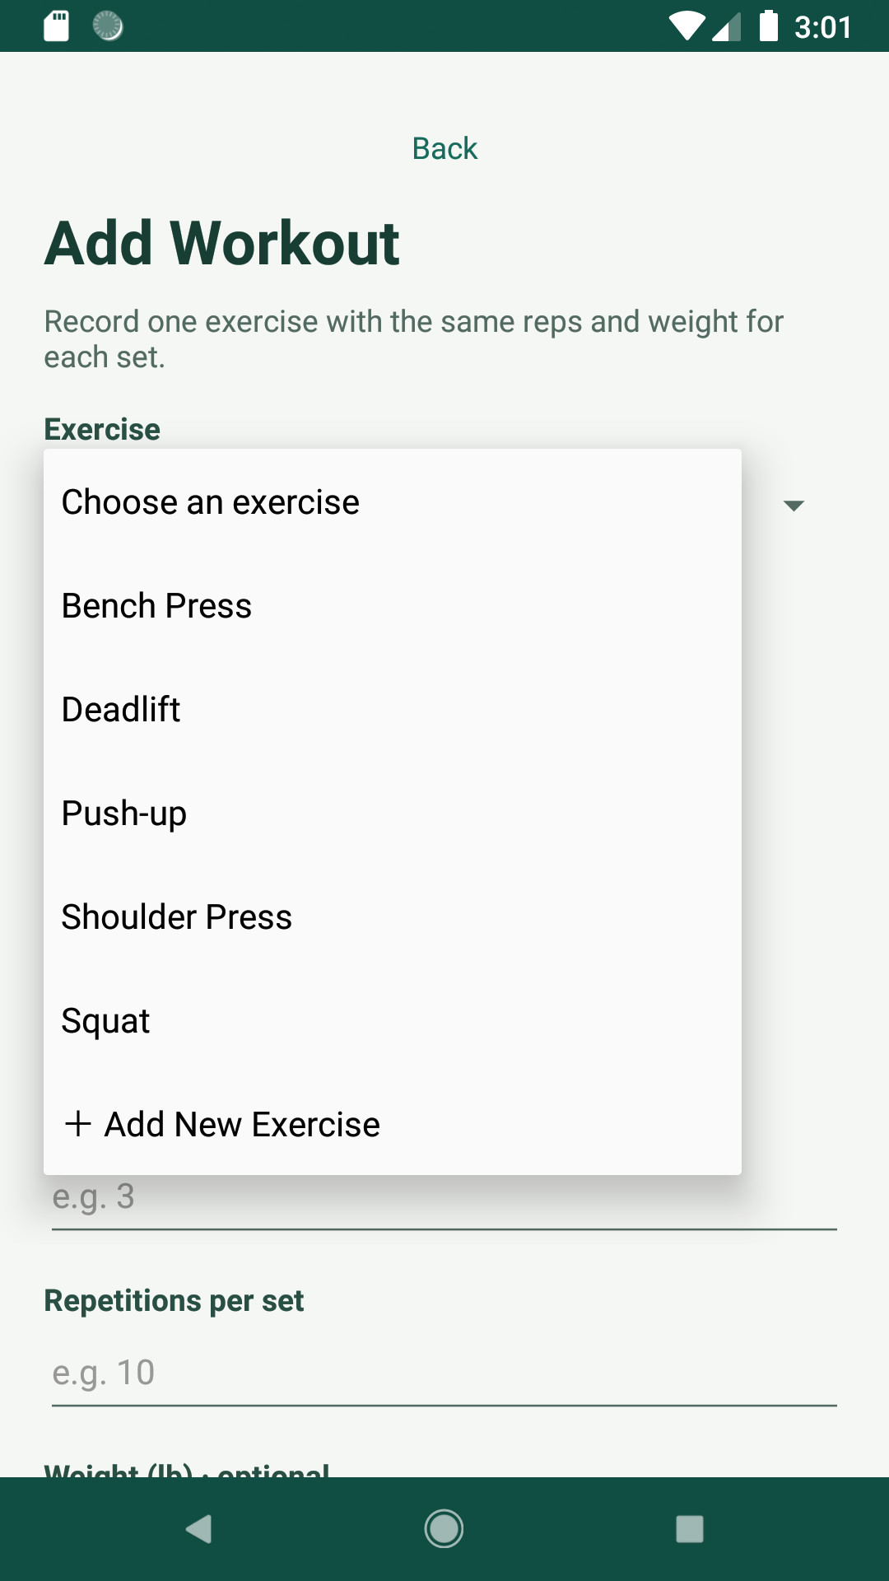
Open the Exercise list and select Add New Exercise
- Select Add New Exercise at the bottom of the Exercise list.
- Enter a unique exercise name.
- Select Choose Image to use a picture from the device or keep the default icon.
- Select Save Exercise. The new exercise returns to the workout form as the selected choice.
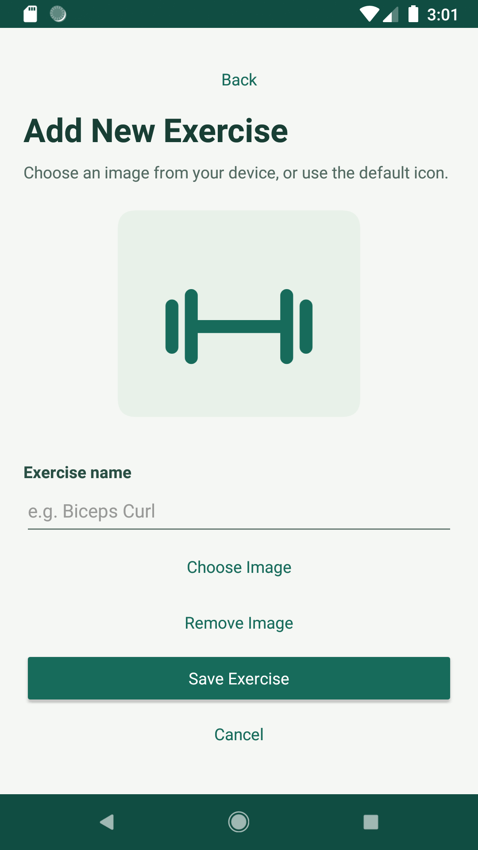
The New Exercise form
Duplicate names Exercise names are checked without regard to capitalization. Use a distinct name for each exercise.

Review Workout History
History lists the newest entries first. Each card shows the exercise date sets repetitions and weight. Select any card to open the full record.
A populated History list

View Edit or Delete an Entry
- Select a workout card in History.
- Review its exercise date sets repetitions weight and notes.
- Scroll down and select Edit Workout to change the entry.
- Select Delete Workout only when you want to remove the entry. Confirm the deletion when prompted.
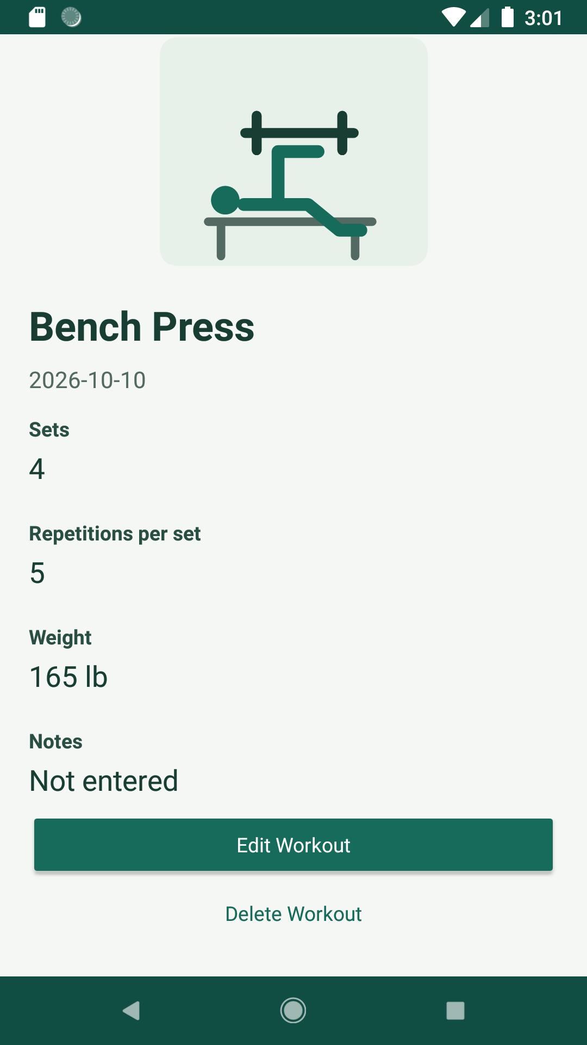
Workout details with Edit Workout and Delete Workout controls

Understand the Progress Dashboard
Select Progress from the tab bar. The dashboard recalculates from saved workouts and can be scrolled from the summary tiles to the charts and records.
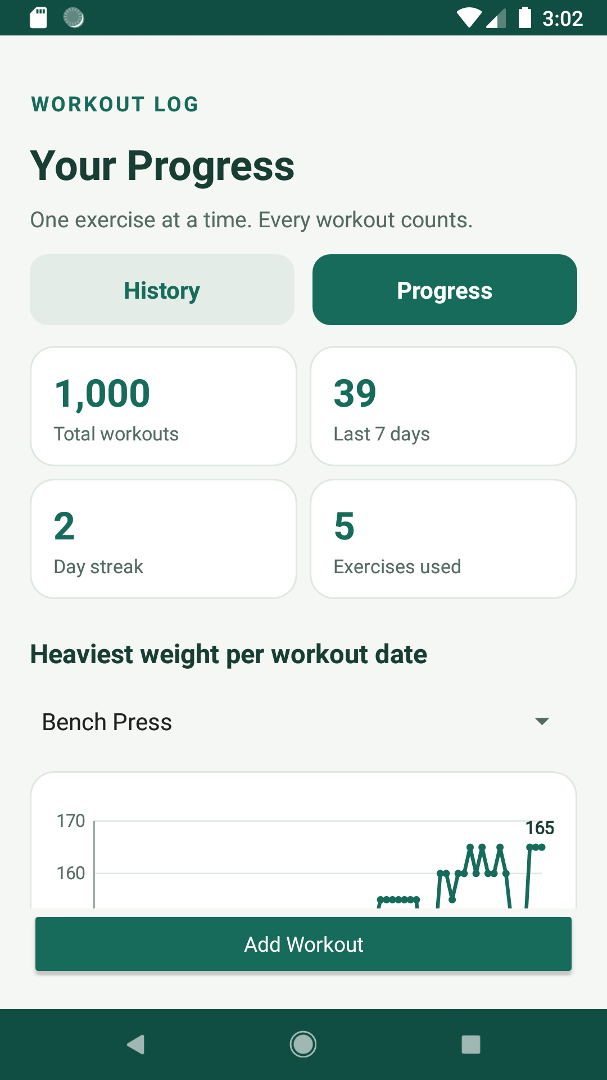
Progress summary and heaviest weight chart
- Total workouts counts every saved workout entry.
- Last 7 days counts entries dated today and the previous six days.
- Day streak counts consecutive workout days ending today, or yesterday if no workout is logged today. Otherwise, the streak is zero.
- Exercises used counts exercises represented in the saved history.
- Heaviest weight per workout date plots the highest saved weight for the selected exercise on each date.

Read Weekly Volume and Record Charts
Continue scrolling in Progress to compare recent activity and total training volume.
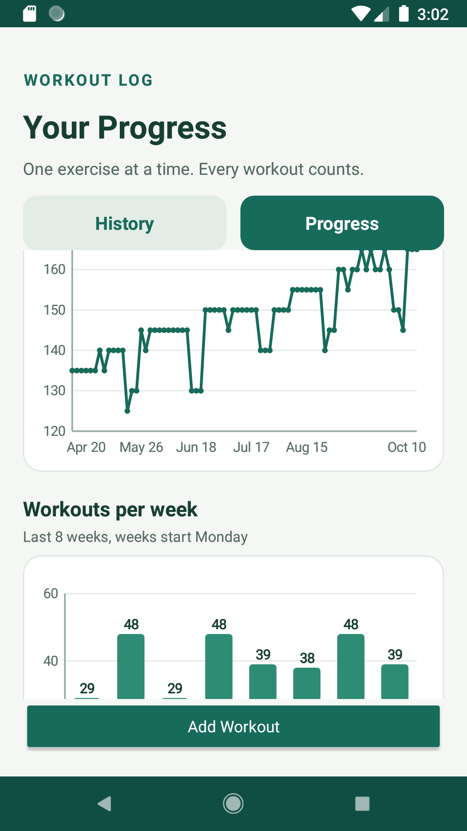
Heaviest weight history and workouts per week
- Workouts per week shows the last eight weeks. Each week begins Monday.
- Top exercises by volume multiplies sets by repetitions by weight and totals the result for each weighted exercise.
- Bodyweight entries without a saved weight do not add pounds to the volume chart.
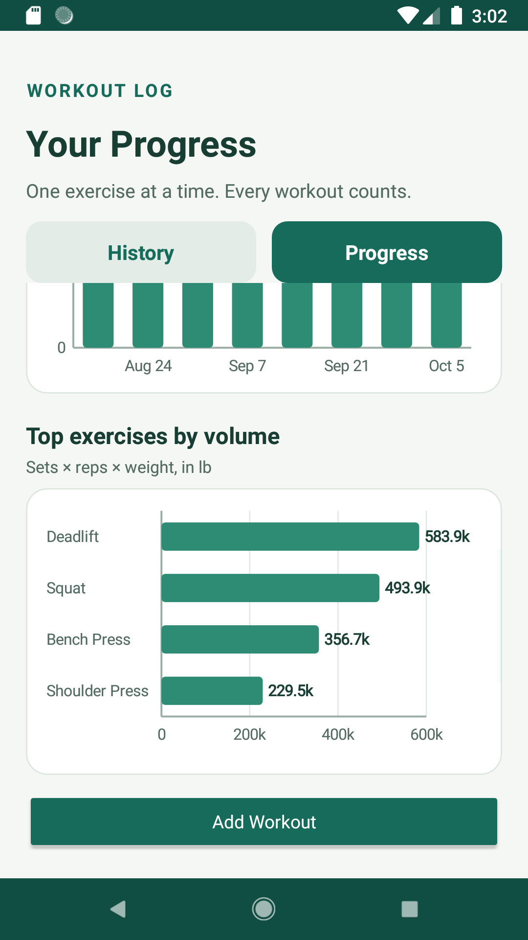
Top exercises by total volume

Review Personal Records
Personal records show the highest saved weight for each weighted exercise and the date it occurred. Scroll to the bottom of Progress to reach this section.
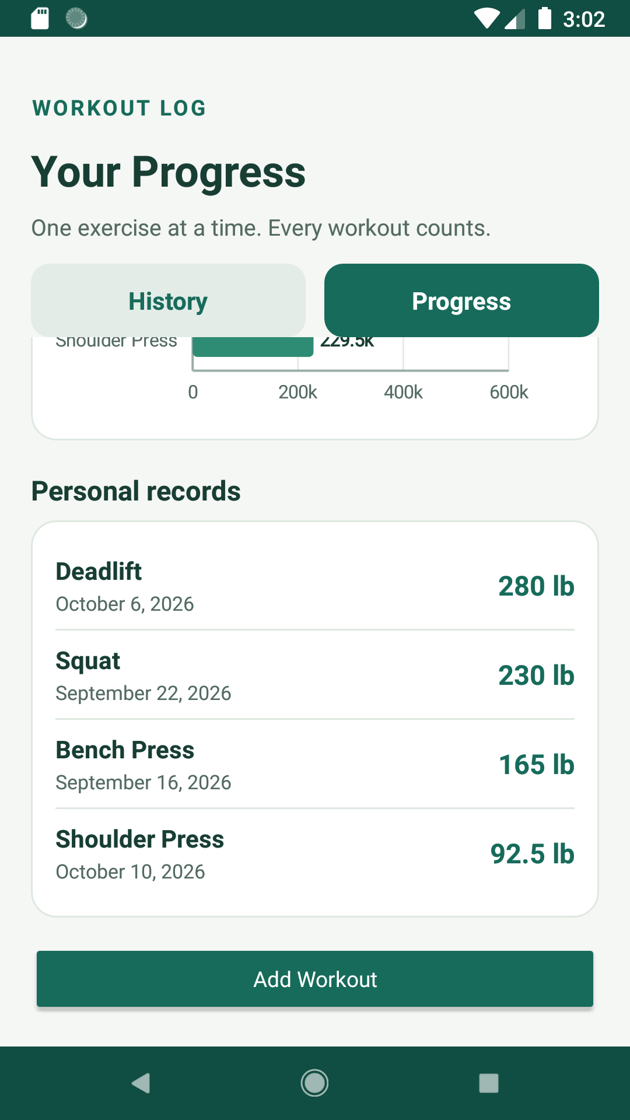
Personal records in the Progress tab
Exercise selector Use the selector above the heaviest weight chart to switch the chart between exercises.

Use Sample Data and Manage History

Load Sample Data
Select Load sample data on the History tab to add about 1,000 demonstration workouts from the previous six months. Existing workouts are kept. This option is useful for exploring the Progress charts before entering your own history.
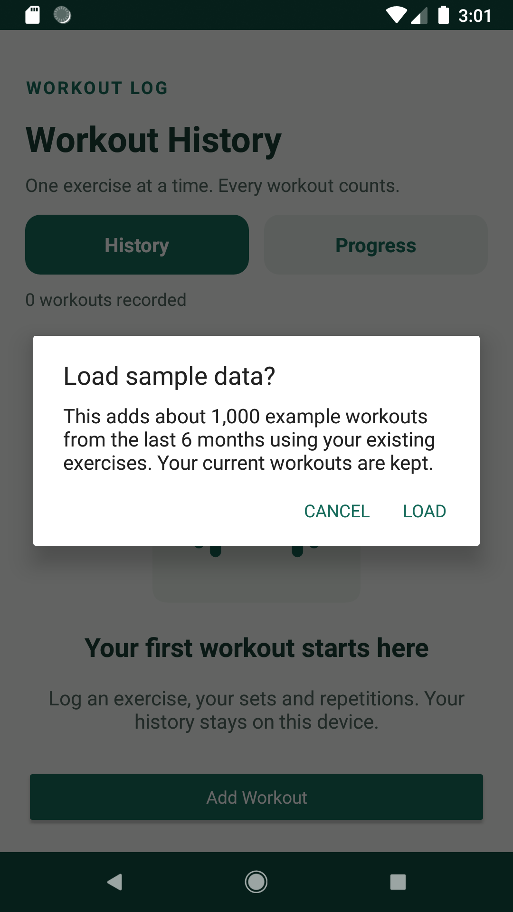
Confirmation shown before sample workouts are added

Delete All Workouts
Select Delete all workouts to clear workout entries after confirming the warning. The exercise list remains available. This action is intended for resetting history and cannot be undone inside the app.
Before clearing history Review the confirmation carefully. Workout Log stores data locally and does not include cloud backup or account recovery.

Field Reference
Field | Required | Purpose
Exercise | Yes | The movement performed in this workout entry.
Workout date | Yes | The workout date, shown as yyyy-MM-dd. Use today or an earlier date.
Sets | Yes | The number of sets completed. Enter a whole number from 1 to 100.
Repetitions per set | Yes | The repetition count for every set. Enter a whole number from 1 to 1,000.
Weight | No | Resistance in pounds, from 0 to 2,000, with up to two decimal places. Leave blank for unweighted entries.
Notes | No | Technique observations, workout context, or reminders. Maximum 500 characters.

Privacy and Storage
Workout Log works offline. Workout records and copied custom exercise images stay in the app storage on the device. The app does not require an account, internet permission, analytics, or cloud services. Uninstalling the app or clearing its storage deletes saved workouts and custom exercises, including their copied images. There is no backup or recovery feature in the app.

Common Questions
Why is Save Workout not working. Check that an exercise date sets and repetitions are entered with valid values.
Why is an exercise missing from volume. The volume chart uses saved weight. Entries without weight do not contribute pounds.
Can I edit or delete a custom exercise. Version 1 supports creating custom exercises but does not include custom exercise editing or deletion.
Can each set have different repetitions or weight. No. One entry applies the same repetitions and weight to every set.

